**CYPRESS**

**Opening Cypress :-**

node_modules/.bin/cypress open

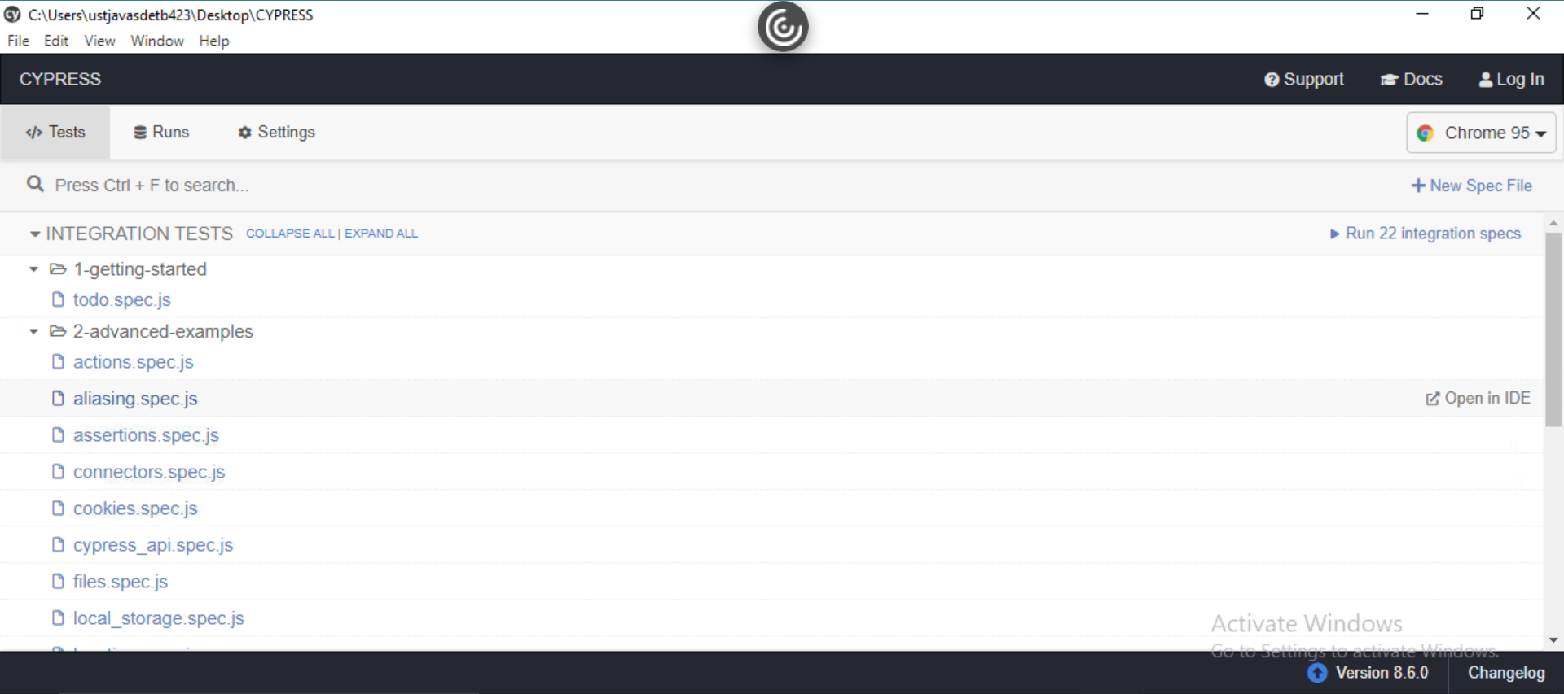

**Create a New Spec File**

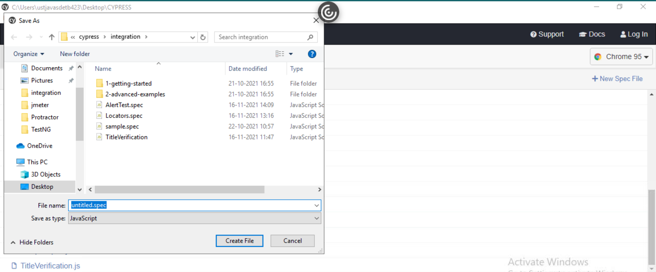

**Cypress Example 1 :-**

// sample.spec.js created with Cypress

//

// Start writing your Cypress tests below!

// If you're unfamiliar with how Cypress works,

// check out the link below and learn how to write your first test:

// <https://on.cypress.io/writing-first-test>

// test suite name

describe('simple Test', function () {

    // Test case

       it('Scenario 1', function (){

          // test step for URL launching

          cy.visit("<https://www.google.com/>");

       });

    });

**Output :-**

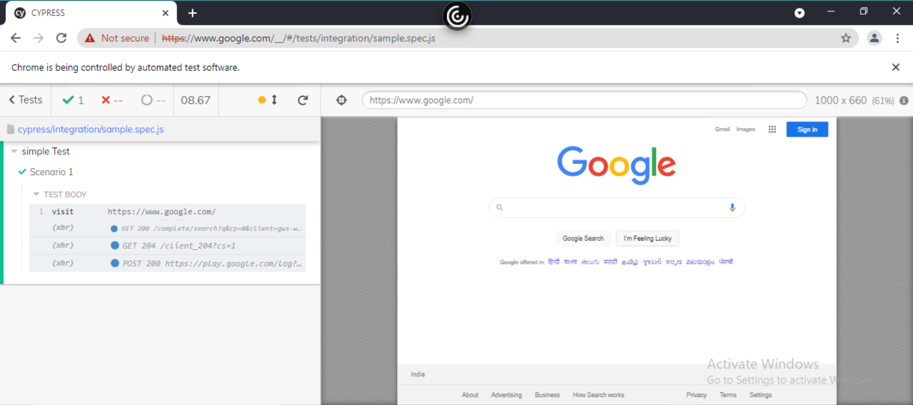

**Running it on Terminal :-**

npx cypress run --spec "C:\Users\ustjavasdetb423\Desktop\CYPRESS\cypress\integration\sample.spec.js

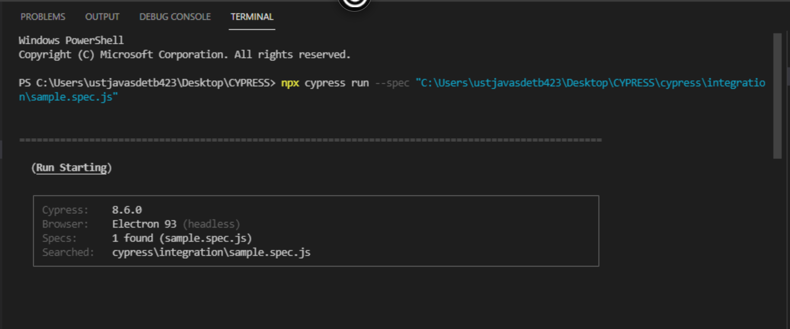

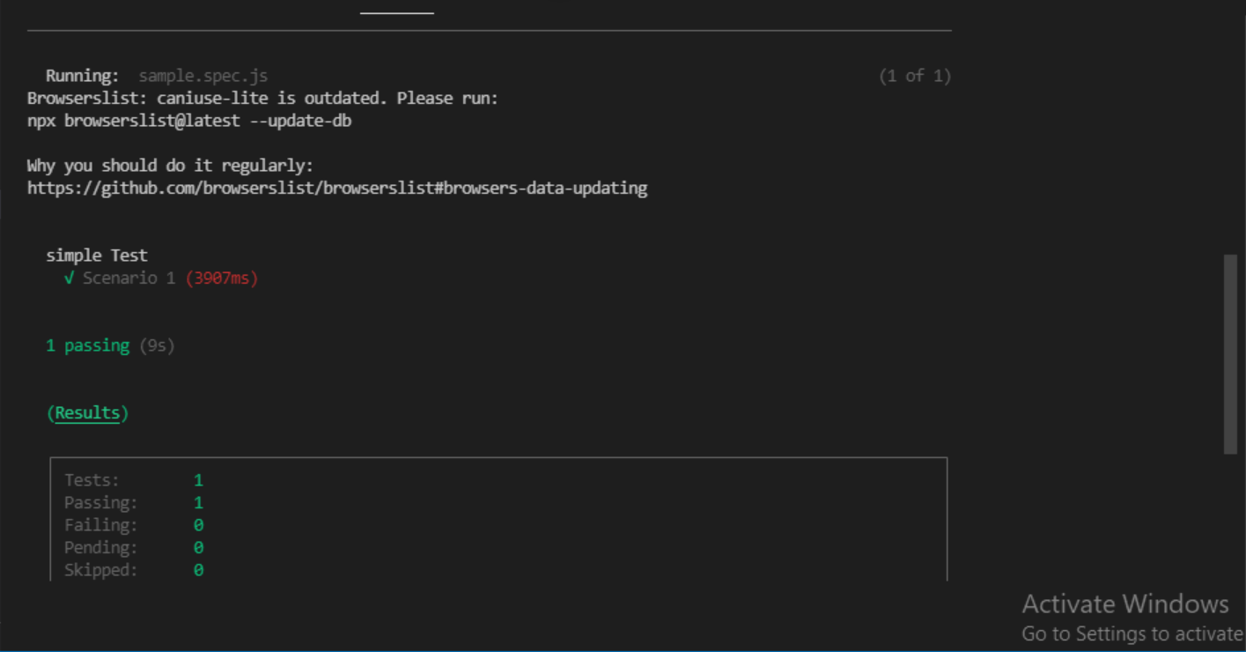

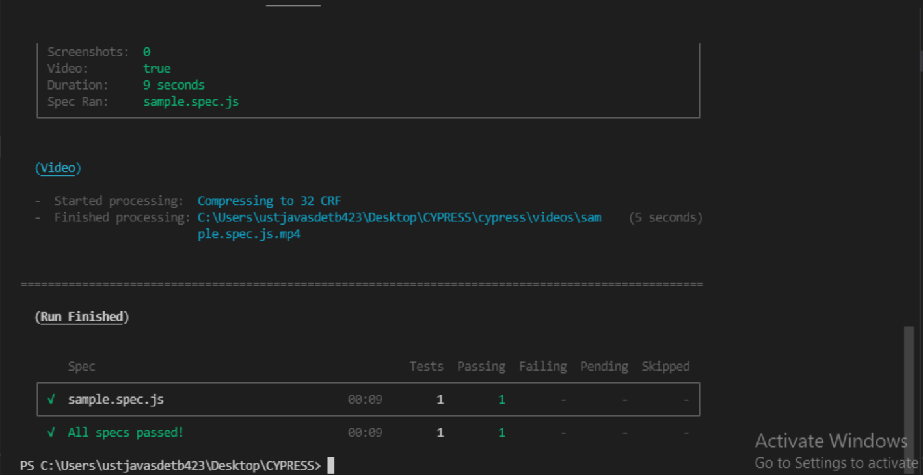

**Cypress Example 2 :-**

// TitleVerification.js created with Cypress

//

// Start writing your Cypress tests below!

// If you're unfamiliar with how Cypress works,

// check out the link below and learn how to write your first test:

// <https://on.cypress.io/writing-first-test>

describe('mysuite', function() {

it('verify the title pos', function() {

cy.visit('<https://demo.nopcommerce.com/>')

cy.title().should('eq', 'nopCommerce demo store')

})

it('verify the title neg', function() {

cy.visit('<https://demo.nopcommerce.com/>')

cy.title().should('eq', 'nopCommerce store')

})

})

**Output :-**

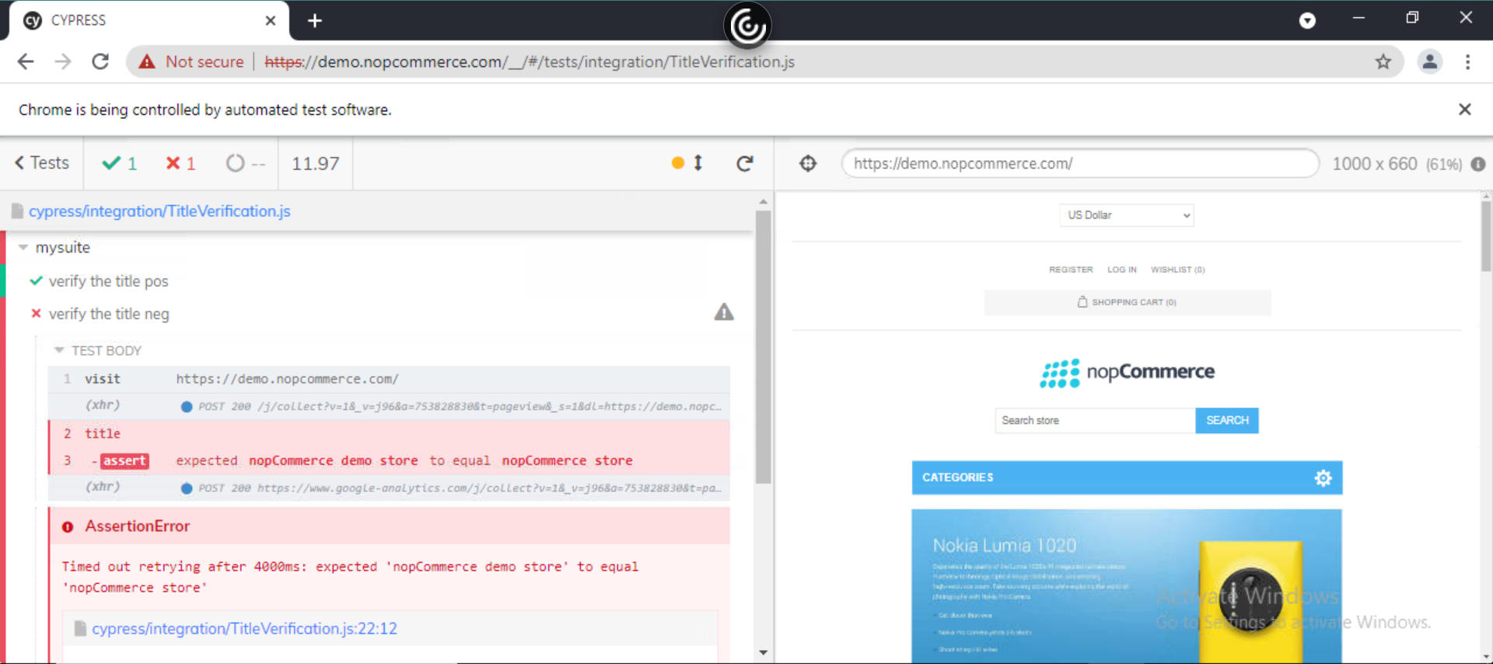

**Running it on Terminal :-**

npx cypress run --spec "C:\Users\ustjavasdetb423\Desktop\CYPRESS\cypress\integration\ TitleVerification.js

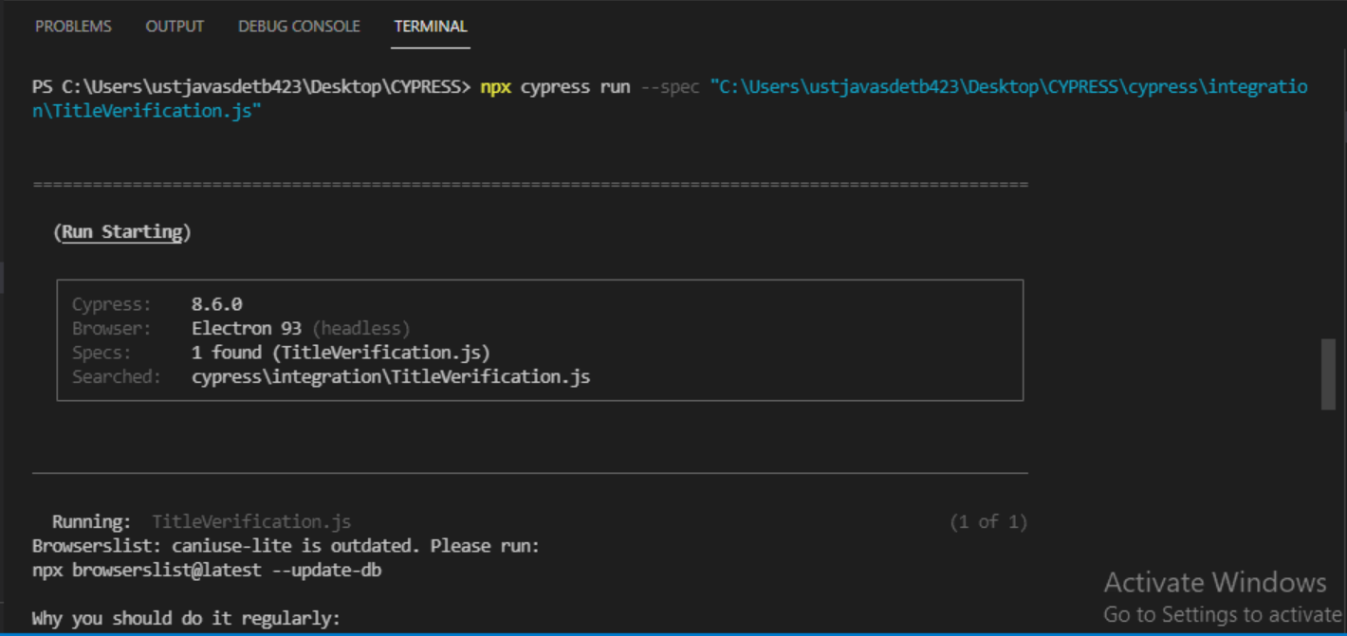

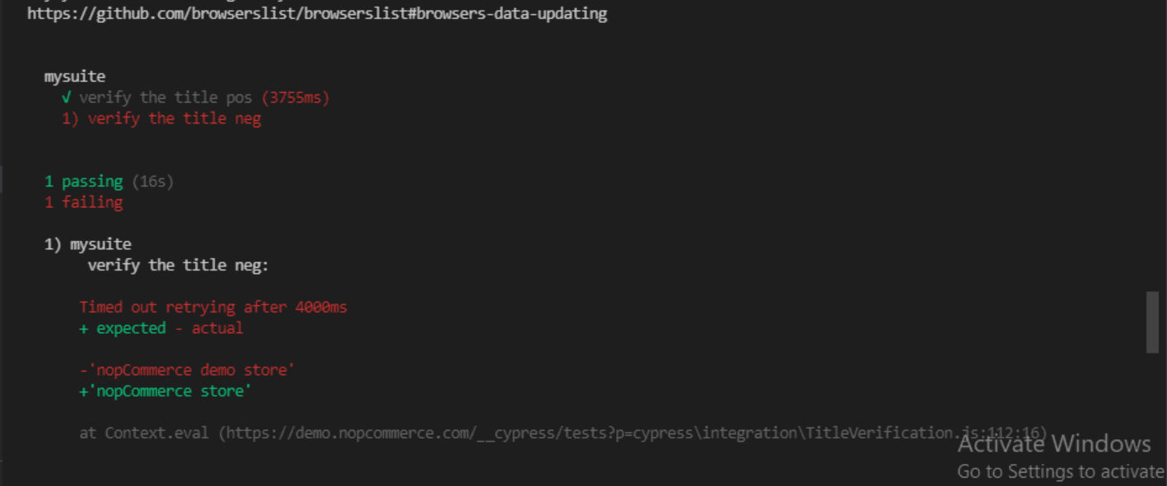

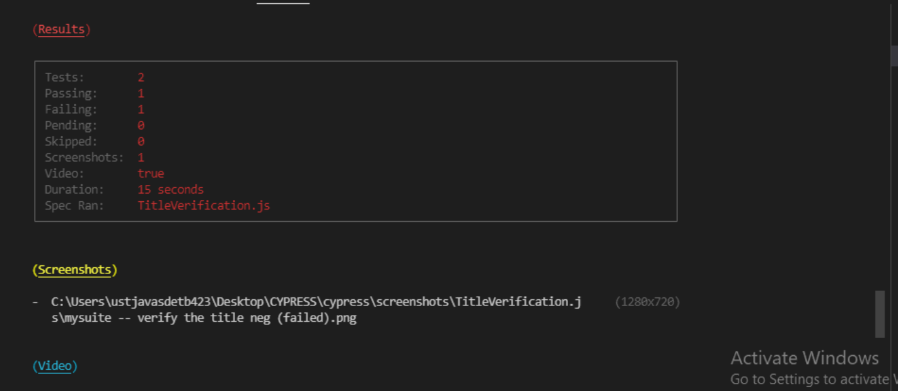

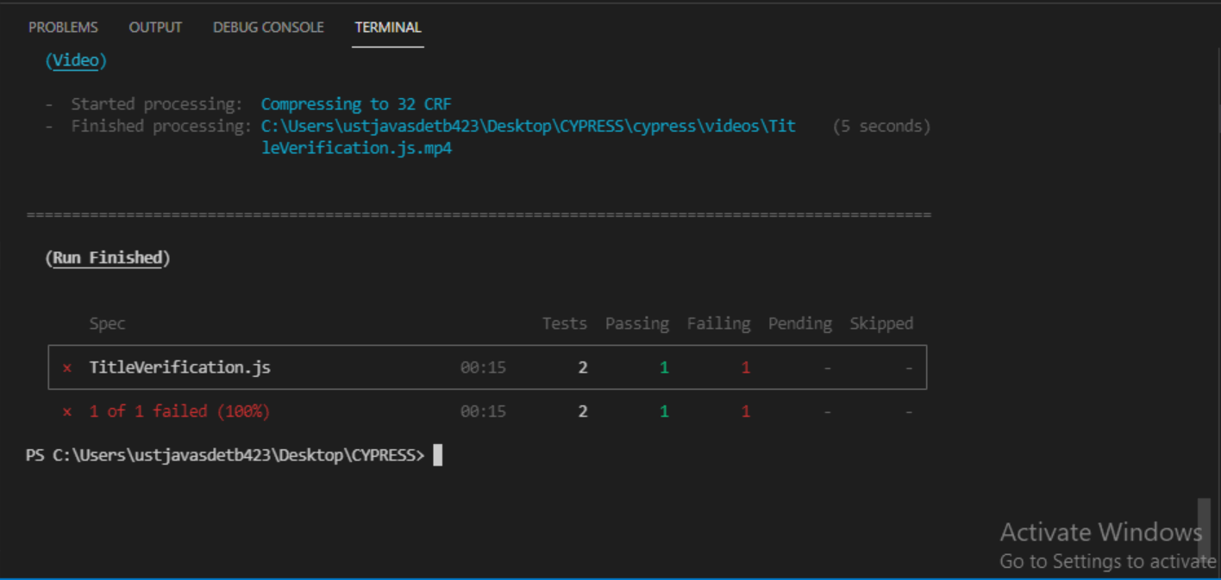

**Screenshot Generated :-**

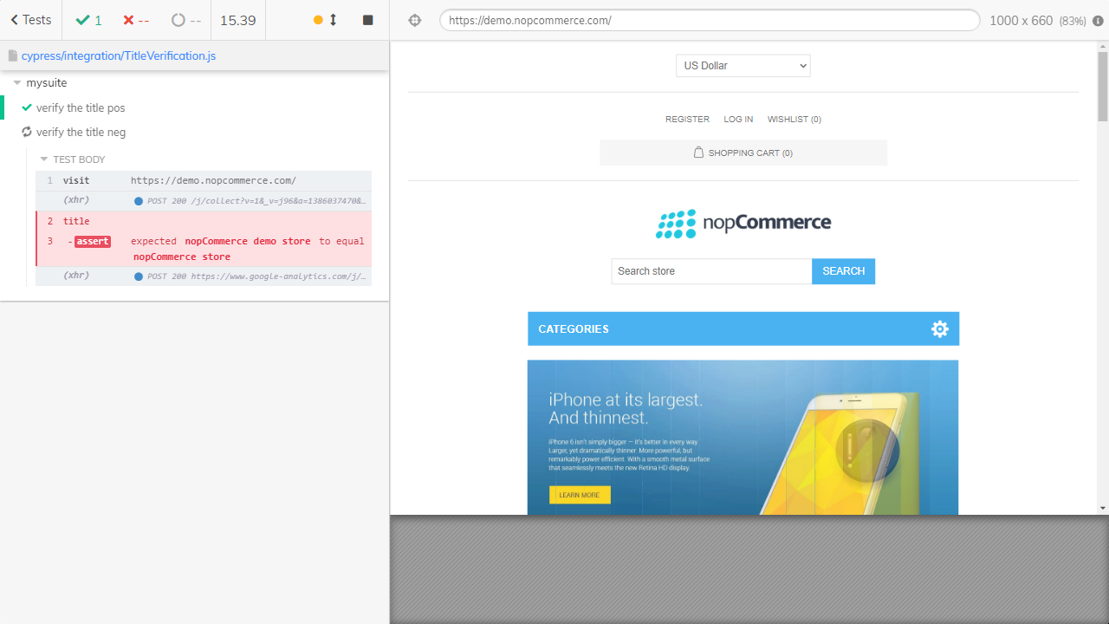

**Cypress Example 3 :-**

// Locators.spec.js created with Cypress

//

// Start writing your Cypress tests below!

// If you're unfamiliar with how Cypress works,

// check out the link below and learn how to write your first test:

// <https://on.cypress.io/writing-first-test>

describe('Locators example', function() {

    it('types of locators', function() {

      cy.visit("<https://demo.nopcommerce.com/>")

      cy.get("#small-searchterms").type("Apple MacBook Pro 13-inch")

      cy.get("[type='submit']").click()

      cy.get("[class='button-2 product-box-add-to-cart-button']").click()

      cy.wait(5000)

      cy.get("[class='prices']").contains('$1,800.00')

    })

})

**Output :-**

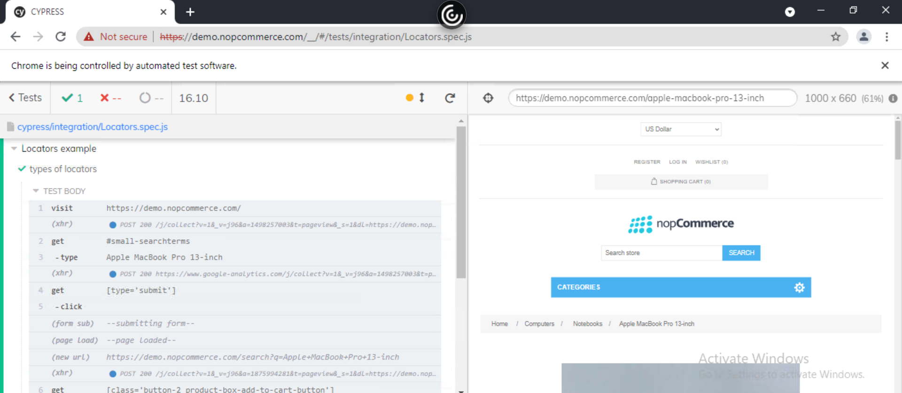

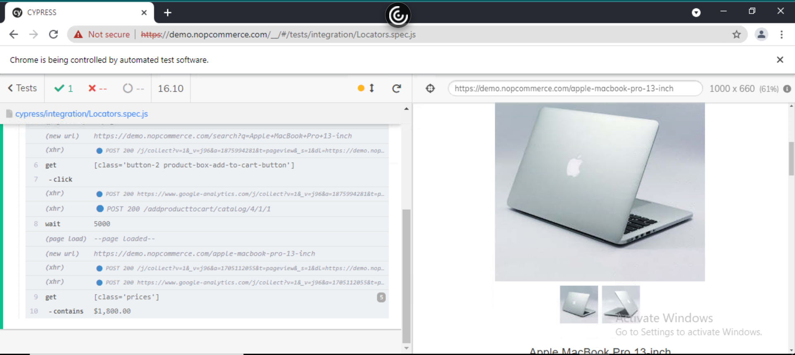

**Running it on Terminal :-**

npx cypress run --spec "C:\Users\ustjavasdetb423\Desktop\CYPRESS\cypress\integration\ Locators.spec.js

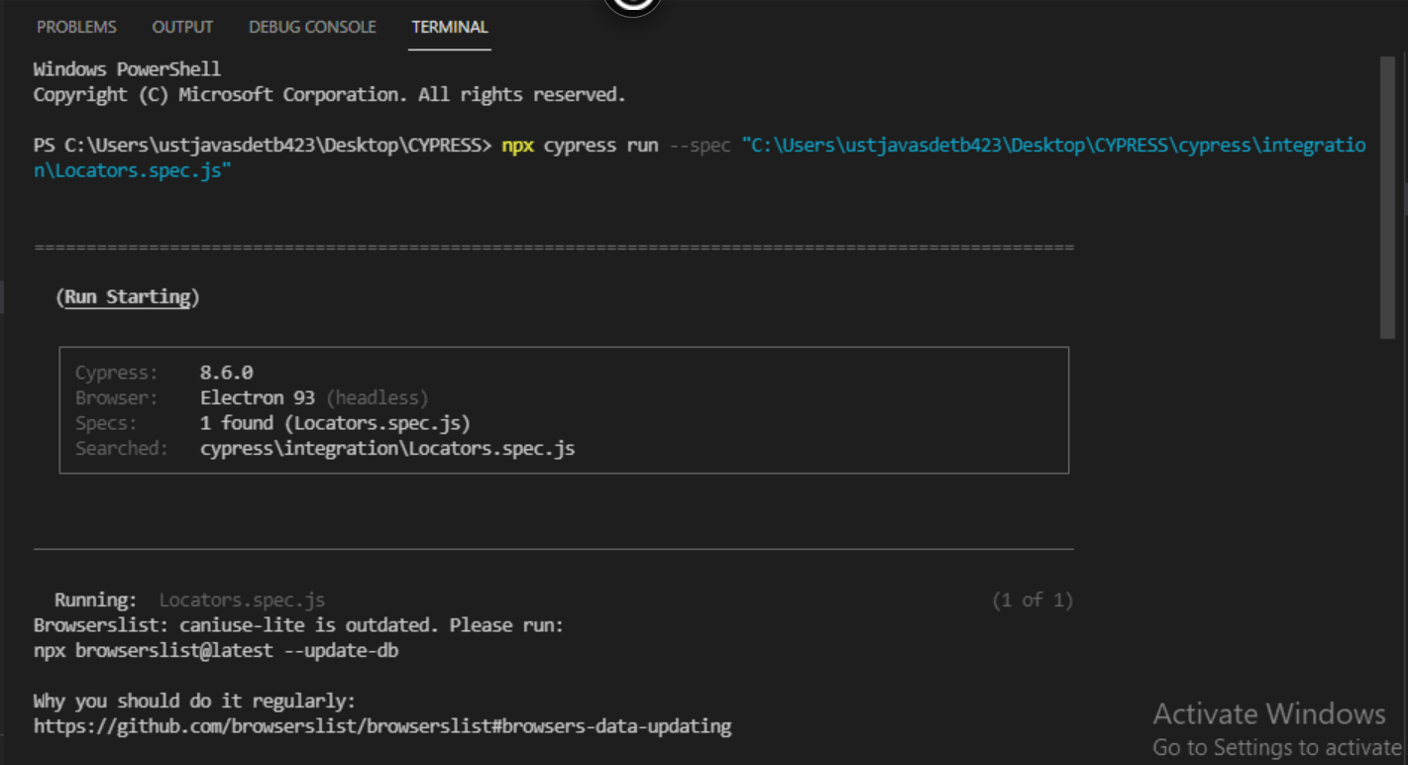

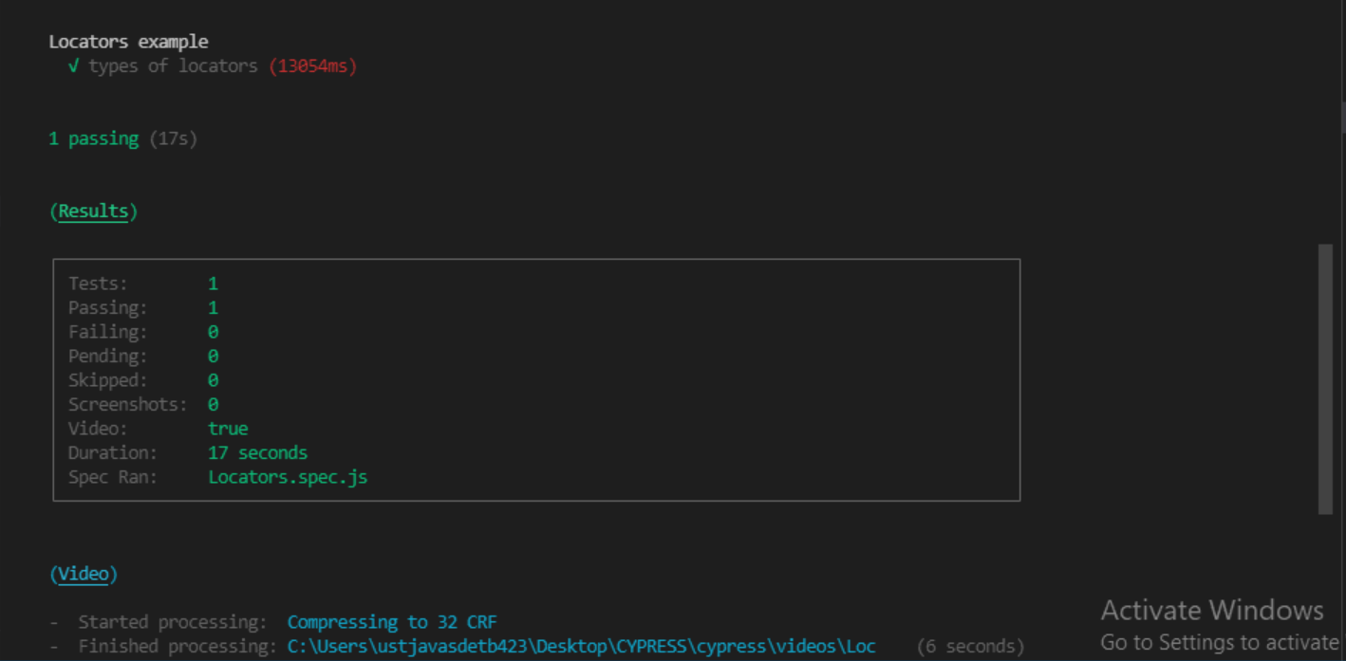

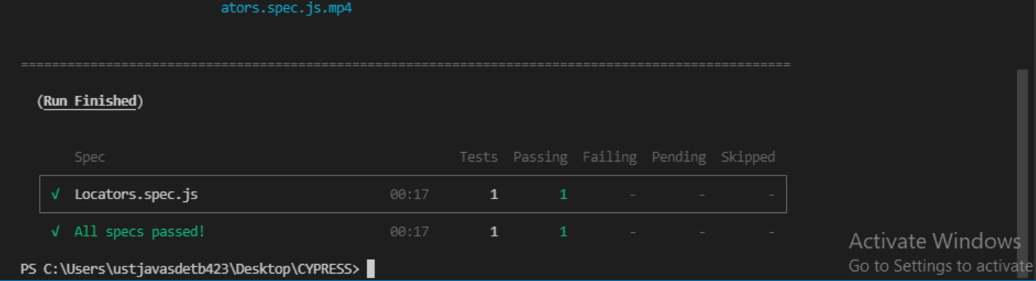

**Cypress Example 4 :-**

// AlertTest.spec.js created with Cypress

//

// Start writing your Cypress tests below!

// If you're unfamiliar with how Cypress works,

// check out the link below and learn how to write your first test:

// <https://on.cypress.io/writing-first-test>

describe('Alert Test', function () {

    // test case

    it('Scenario 1', function (){

       // launch url

       cy.visit("<https://register.rediff.com/register/register.php>");

       // click submit

       cy.get('input[type="submit"]').click();

       // fire event with method on

       cy.on('window:alert',(t)=>{

          //assertions

          expect(t).to.contains('Your full name');

       })

    });

 });

**Outputs :-**

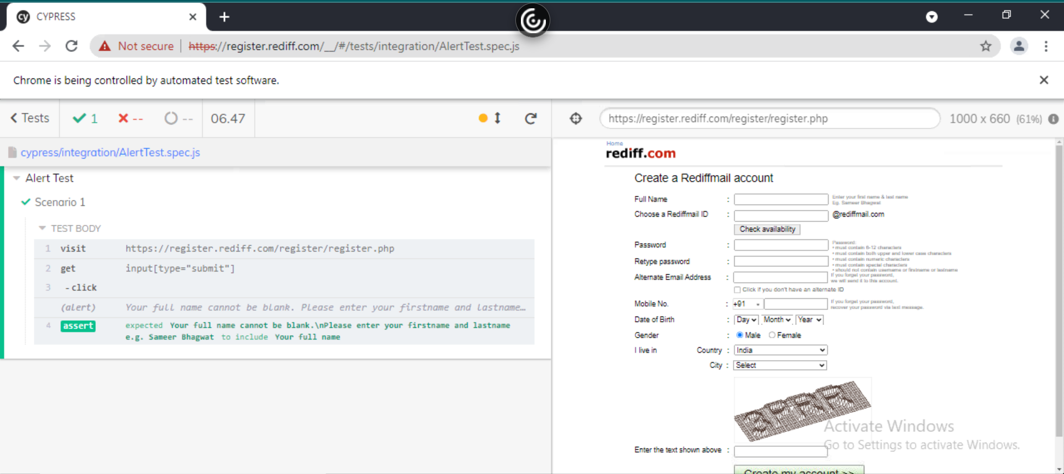

**Running it on Terminal :-**

npx cypress run --spec "C:\Users\ustjavasdetb423\Desktop\CYPRESS\cypress\integration\ AlertTest.spec.js

